|  |  |
| --- | --- |
| **AP Computer Science** | **TextLab07 Java Assignment** |
| **The "Magic Square" Program** | **80, 100 & 110 Point Versions** |
| **Assignment Purpose:**  The purpose of this program is to manipulate two-dimensional arrays. | |

Write a program that creates odd-sized **Magic Squares**. A magic square is a square matrix of consecutive numbers, such that the numbers in the rows, the numbers in the columns, and the numbers in the diagonals add up to the same sum. For this program you will only be concerned with **“odd-sized”** magic squares. Odd refers to the size of the matrix, such as an 3 X 3, or an 5 X 5, or an 9 X 9 sized matrix.

Examples of a 3 X 3 magic square and a 5 X 5 magic square are shown below:

|  |  |  |
| --- | --- | --- |
| **8** | **1** | **6** |
| **3** | **5** | **7** |
| **4** | **9** | **2** |

Every row, column and diagonal in the 3 X 3 matrix adds up to 15.

|  |  |  |  |  |
| --- | --- | --- | --- | --- |
| **17** | **24** | **1** | **8** | **14** |
| **23** | **5** | **7** | **14** | **16** |
| **4** | **6** | **13** | **20** | **22** |
| **10** | **12** | **19** | **21** | **3** |
| **11** | **18** | **25** | **2** | **9** |

Every row, column and diagonal in the 5 X 5 matrix adds up to 65.

The magic square program is quite challenging, and comes in two different levels of difficulty. It is very important that you first are able to create magic squares, of any odd size, yourself on paper. On the next page is a five-step algorithm to create an odd magic square. Study these steps carefully and use them to create magic squares on paper. Only after you are confident that you understand the magic square algorithm, are you ready to proceed to write a program.

**Magic Square Algorithm:**

The creation of a magic square involves using the following algorithm. It will be your assignment to translate this algorithm into a program.

[1] Start number **1** in the **top row**, **middle column**.

[2] Place consecutive integers in a **diagonally-up-to-the-right** pattern.

[3] Any number that goes outside the matrix **above row 1** is moved to the **bottom row**.

[4] Any number that goes outside the matrix past the **right column** is moved to the **left column**.

[5] Any number, which follows the **multiple of the matrix size**, is moved **down 1 row**.

**80 Point Version**

The 80-point version enters the magic square size in a text window prompt. This should be a number in the [3..17] integer range. It is not necessary to protect against erroneous input. Two methods are called from the main method. First, complete computeMagicSquare, which places consecutive integers in the proper matrix locations. Second, displayMagicSquare, which displays the values of the matrix.

Numbers for all versions of this assignment need to use a three digits "000" decimal format.

Important Hint: Place each consecutive number, starting at 1, in the correct matrix location, not the other way around. Think what you do when you create a magic square on paper. You start by placing number 1 in the right place, then number 2, number 3 and so on.

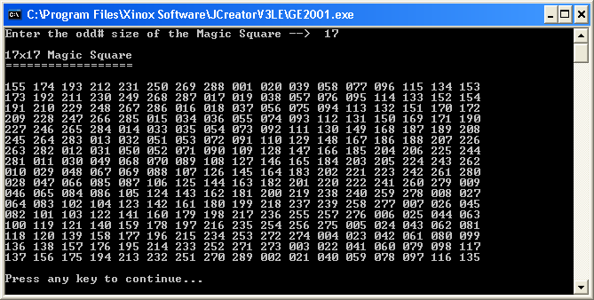

**100 Point Version**

The 100-point version adds 3 methods. These methods are checkrows, checkColumns, and checkDiagonals. The purpose of all 3 of these methods is to prove the magic square is truly a magic square by adding up and displaying the sums of all of the numbers in every row, every column, and both diagonals. All of the sums should be identical. For this version, the 3 methods only display the sums.

|  |
| --- |
| **Magic Square Sum Rule** |
| The sum of the rows, columns and diagonals in an odd magic square will always be the size of the square times the median number in the square.  In a 3 X 3 that means **3 * 5 = 15**.  In a 5 X 5 that means **5 * 13 = 65**. |

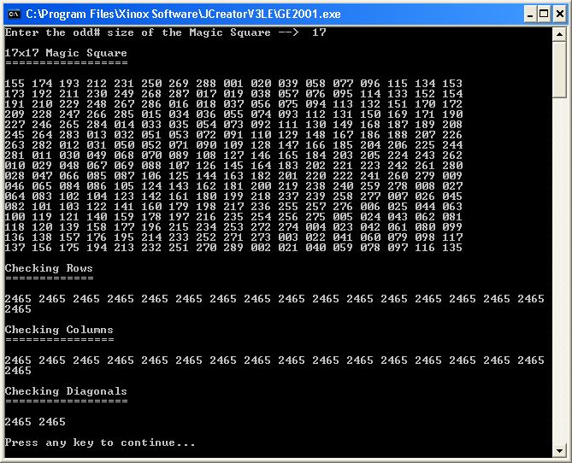

**110 Point Version**

The 110-point version improves the checkrows, checkColumns, and checkDiagonals methods. Now you need to actually see all of the numbers in every row, every column, and both diagonals add up to the same sum. See the sample output below:

